**Online Course Analytics | Integrated with Studify Web Platform | Azure-Powered**

## Project Overview

This Power BI dashboard was designed to help instructors on the **Studify** platform (similar to Udemy) monitor course performance, student engagement, and financial outcomes.

-The dashboard is published to **Power BI Service**, and it was shared with the **.NET development team**, allowing them to **embed it in the website** on each instructor's profile page.  
-The data is sourced directly from an **Azure SQL Database** using **Direct Query**, ensuring **real-time automatic data updates** without manual refresh.  
- A complete **data model** was built in Power BI to optimize performance, relationships, and calculations across multiple tables.

## Data Architecture

* **Data Source**: Microsoft Azure SQL Database
* **Connection Type**: Direct Query (real-time updates)
* **Data Modeling**: Relationships, calculated columns, measures using DAX
* **Hosting**: Power BI Service
* **Frontend Integration**: Embedded in ASP.NET instructor pages using InstructorID parameter

### ****Data Model****

The model is designed using a **star schema**, optimized for performance and scalability. It includes:

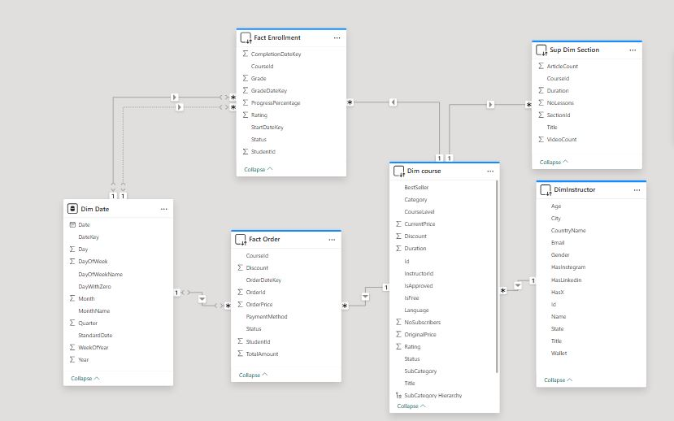

* **DimInstructors** – Instructor profiles
* **DimCourses** – Course metadata
* **FactEnrollments** – Course participation and progress
* FactOrders -payment information
* **DimDate** – Time-based analysis

## ****Dashboard Features****

### ****1. Course Overview Dashboard (Instructor View)****

#### **Key Metrics**

* Total Courses Created: 12
* Total Students Reached: 3,740
* Average Course Rating: 4.3
* Average Completion Rate: 61%

#### **Key Insights**

* Top-performing course: "Mastering Power BI" with 1,200 students
* Highest-rated course: "Advanced SQL" (4.7 stars)
* Most enrolled category: Data Analysis
* Significant drop-off in student progress beyond 50% completion in long-format courses

#### **Recommendations**

* Expand on Power BI content, considering it drives the most engagement
* Shorten longer courses or break them into modules to improve completion rates
* Launch a marketing campaign around “Advanced SQL” to capitalize on high ratings

### ****2. Student Engagement Dashboard****

#### **Key Metrics**

* Average Time Spent per Course: 7.5 hours
* Most Active Time: Evenings (6PM–10PM)
* Repeat Students: 28%
* Discussion Participation Rate: 12%

#### **Key Insights**

* Students are more active mid-week (Tuesdays and Wednesdays)
* High correlation between instructor response time and student rating
* Discussion forums are underutilized

#### **Recommendations**

* Host live sessions mid-week during peak hours
* Encourage students to use discussion boards by posting starter questions
* Implement an automated reply system to boost interaction

### ****3. Earnings & Ratings Dashboard****

#### **Key Metrics**

* Total Earnings: $18,500
* Monthly Average: $1,542
* Highest Grossing Course: "Data Visualization Essentials"
* Refund Rate: 2.1%

#### **Key Insights**

* Courses priced between $15–$25 have the best ROI
* Refunds mostly stem from unclear course expectations
* Ratings improve significantly when instructors update content regularly

#### **Recommendations**

* Maintain courses in the optimal pricing tier ($15–$25)
* Regularly update course descriptions and include preview videos
* Offer course bundles or subscriptions to increase recurring revenue

## ****Technical Implementation****

The solution architecture follows this pipeline:

1. **Azure SQL Database** → Centralized course and user data
2. **Power BI Model** → Built on DirectQuery for live analysis
3. **Dashboards in Power BI** → Filtered using parameters for instructor ID
4. **Power BI Service** → Hosts the published dashboards

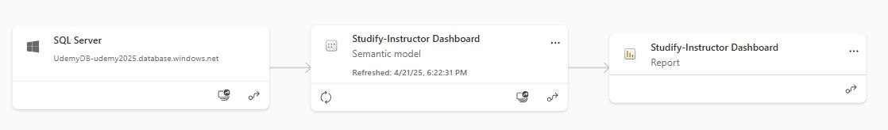

1. **.NET-Based Platform** → Embeds reports with dynamic instructor filtering

## ****Dynamic Filtering Mechanism****

To personalize dashboards for each instructor:

1. Instructor logs in through the platform
2. The system appends their unique ID as a parameter to the embedded report URL
3. Power BI filters all visuals based on the instructor’s ID
4. Each instructor sees only their data (row-level security in action)

## ****User Experience****

Each instructor accesses dashboards tailored to their activities:

* Course creation and student engagement stats
* Revenue breakdowns and performance trends
* Ratings and student feedback analytics

This dynamic and secure dashboard enables instructors to make informed decisions, track performance in real-time, and improve their course offerings.